

THE HERITAGE

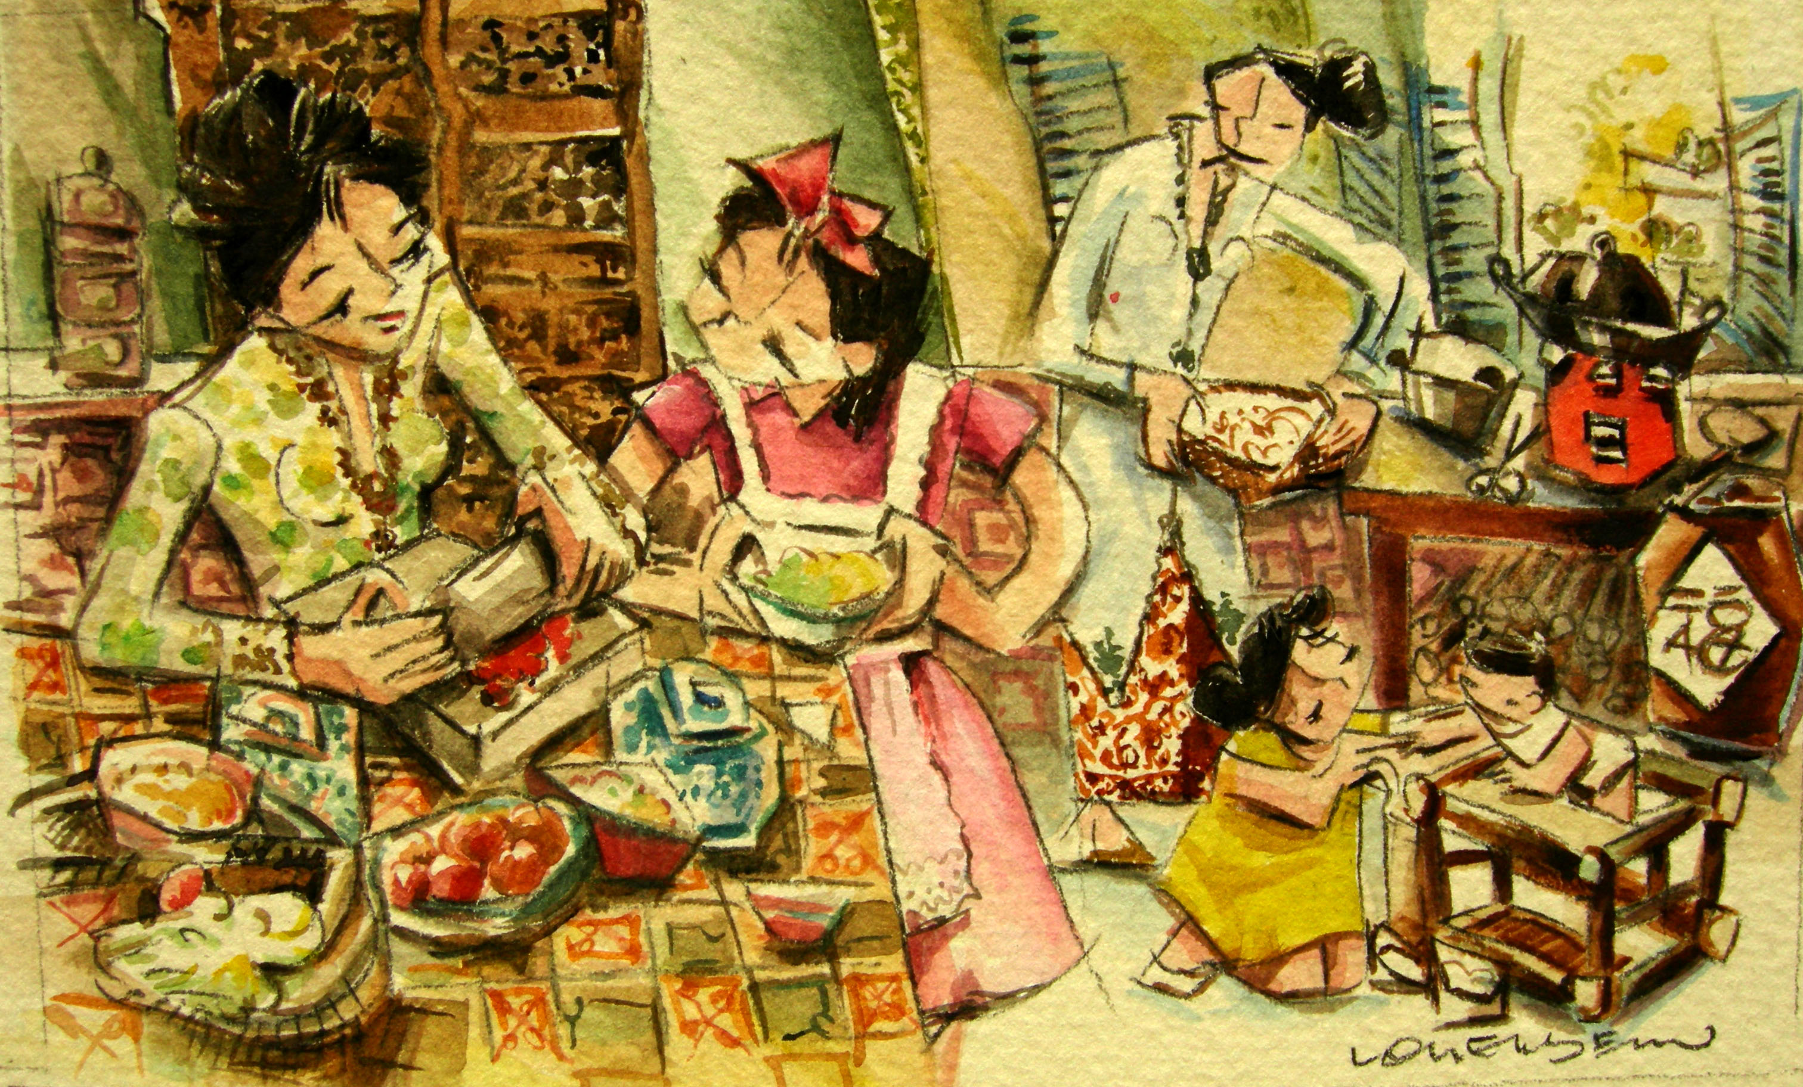
Hari Menyambal
On this day, sambal, as many as 20 or more varieties will be cooked. The serving of this
dish represents the harmony of the impending
match.

